MYSQL Installation Windows:

**Important Note**

**Requirement:** Visual C++ Redistributable for Visual Studio 2013

Now we need to perform the following steps

In order to install MySQL on windows we need to perform following stuff

Navigate to <https://dev.mysql.com/downloads/windows/installer/5.7.html>

Now we need to install MySQL server click on following screen below on above page.



This would take some time to download.

Next, click on the MSI installer executable.

Click next of the next window like the one you see below:

‘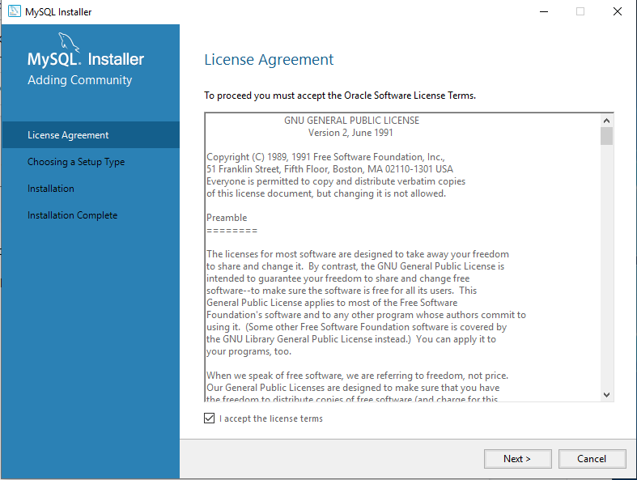

To install requirements, we need to click on execute button shown below:

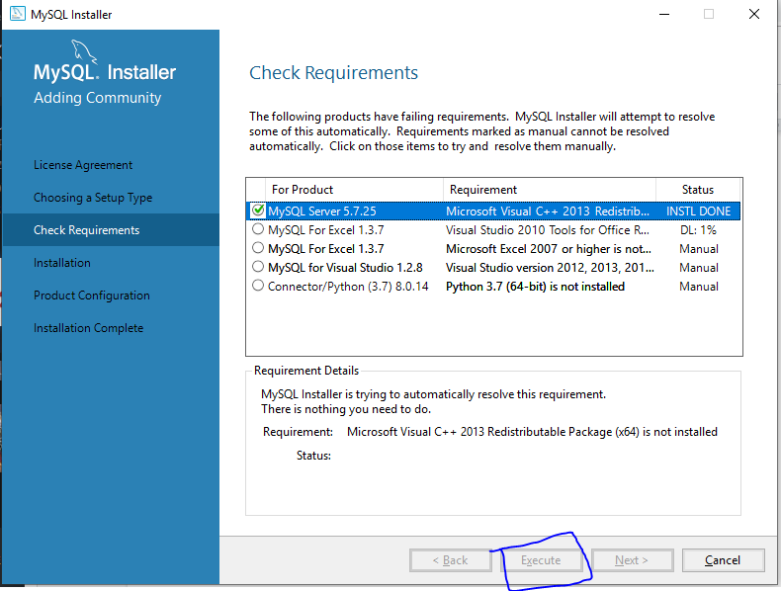

As we want to install mysql for the web development purpose we will choose “Developer Default” ,I am considering you don’t need Microsoft Visual Studio and click “Next”. We need to make sure following options are preselected.

* MySQL Server

* MySQL Shell

The new MySQL client application to manage MySQL Servers and InnoDB cluster instances.

* MySQL Router

High availability router daemon for InnoDB cluster setups to be installed on application nodes.

* MySQL Workbench

The GUI application to develop for and manage the server.

* MySQL for Excel

Excel plug-in to easily access and manipulate MySQL data.

* MySQL Connectors

.

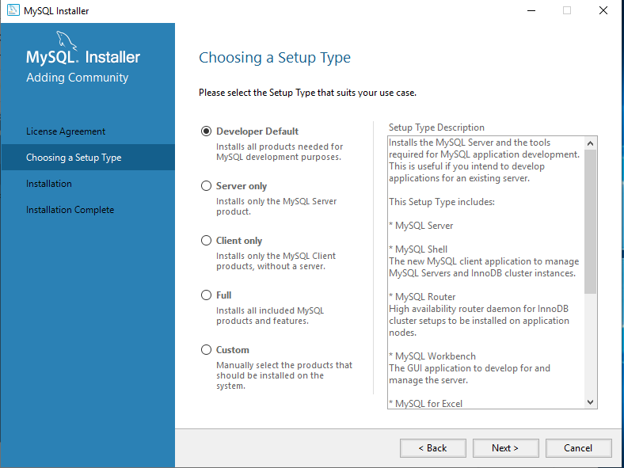

On next window click on “Execute” button as shown below.

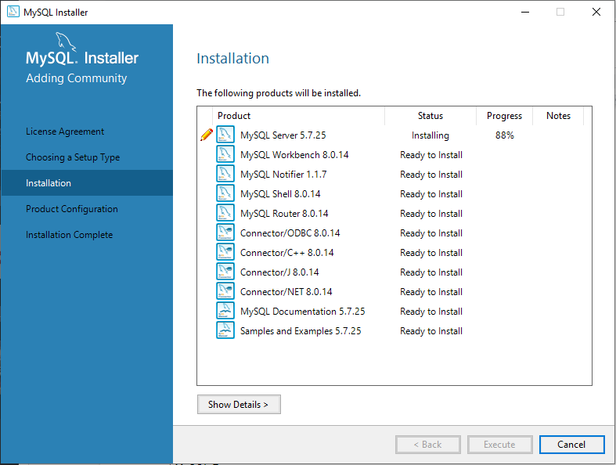

This will install all the packages we’ve selected. Now wait for the installation to finish with your finger crossed :)

Next we would need to configure “MySQL Server” , click on first option and click “Next” like shown in next window:

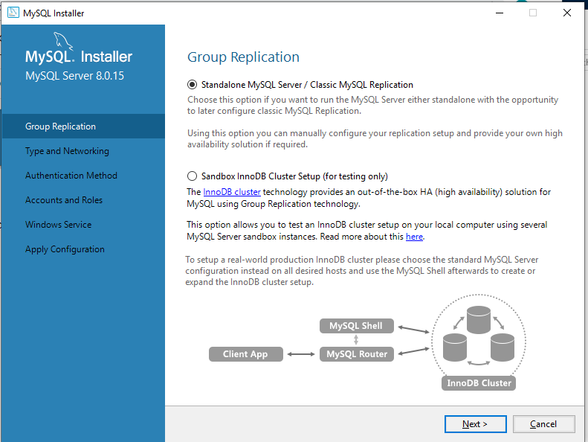

Because we are doing it for development only, we will select “Development Computer” and rest of the configuration to default, like shown in the window below:

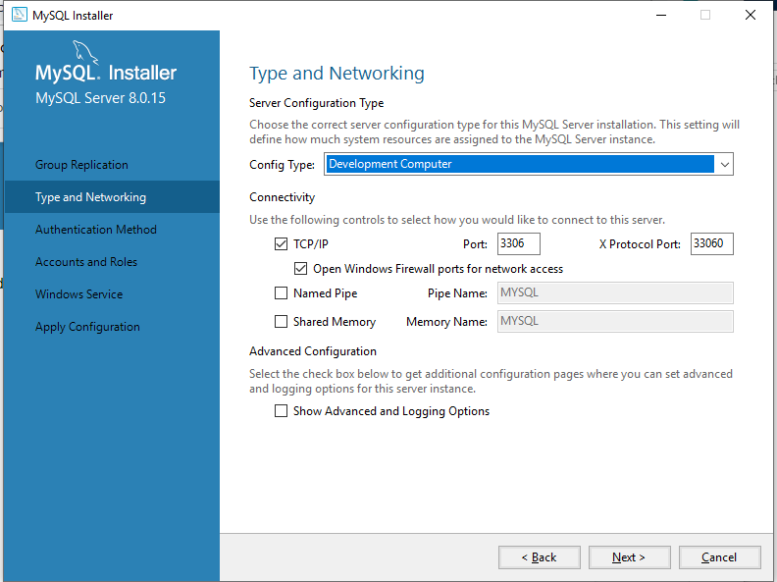

Now let’s the Account Root Password and in case you want to add the local window user in MySQL feel free to add them below and click on Next::

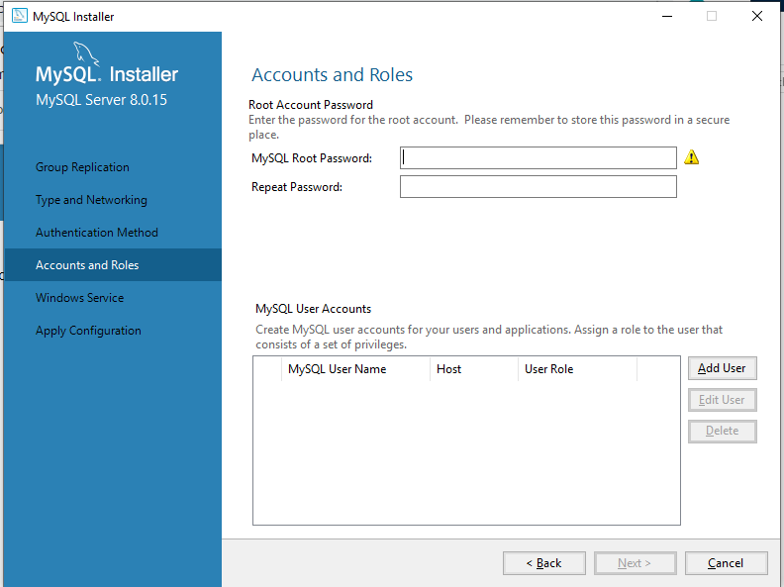

Next we need to configure Windows Service, keep the selected settings as shown in windows below:

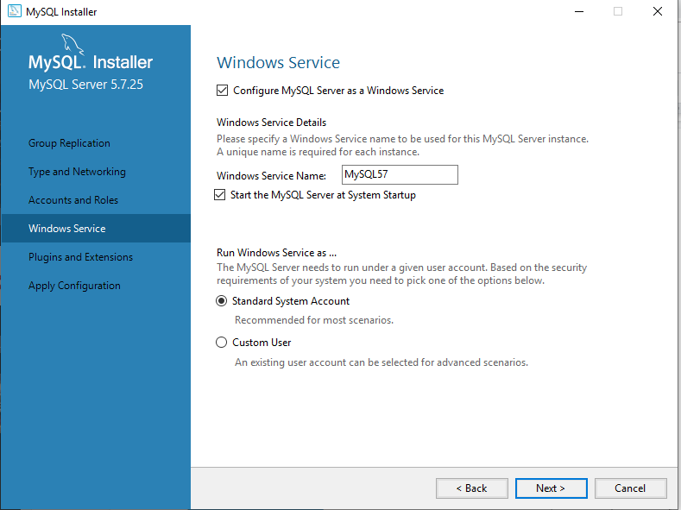

Hit “Execute” on next window. Let the service run and watch the magic :)

You can just hit “Finish” on next window as we don’t have InnoDB cluster, we are not going to do anything here.

On next window we would need to configure the examples and Read docs.

On Next window provide the root password and hit “Check” as shown in window below:

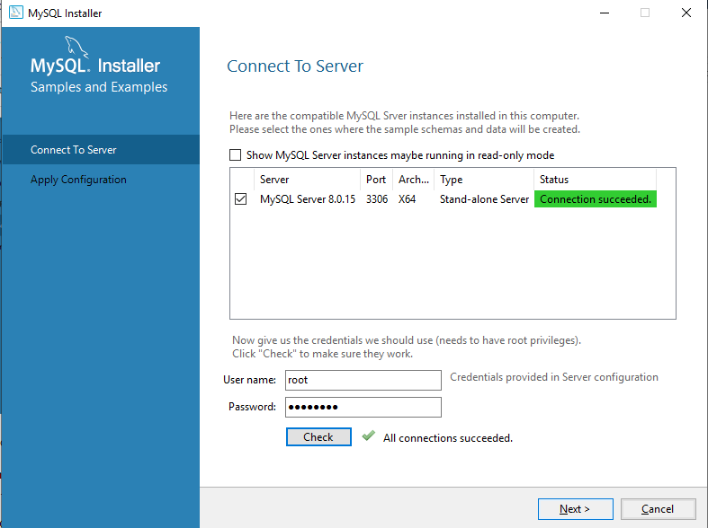

Once you click next the next window have “Execute” option click on it and we’re done!, the setup is complete

Finally, we would need to select the options and hit finish , refer to window below:

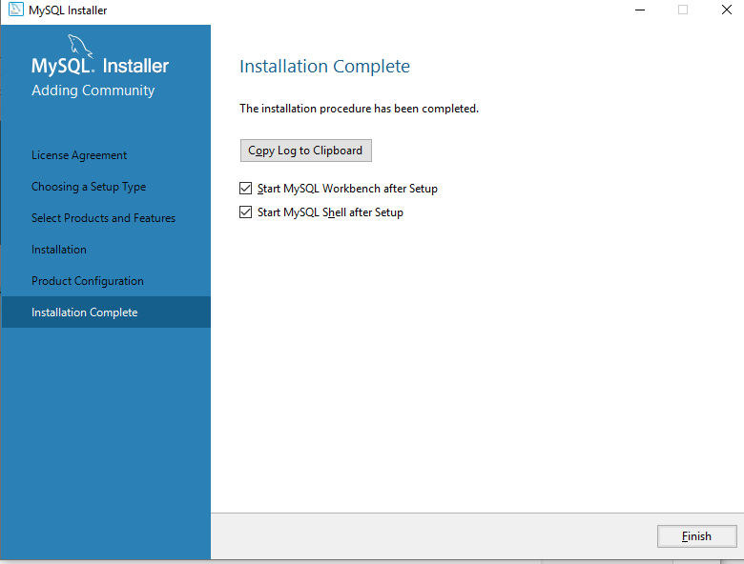

**Starting, Stopping MySQL Service**

In order to start and stop mysql service you first need to open run prompt with “win + r” and type services.msc and hit ok the prompt will open like this

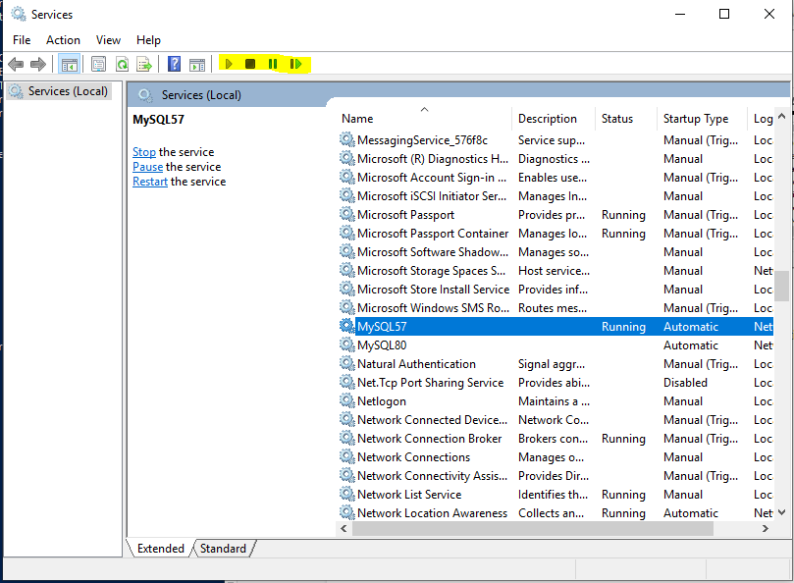

To start MySQL:

Look for mysql service and right click on or use buttons above to start service like shown below

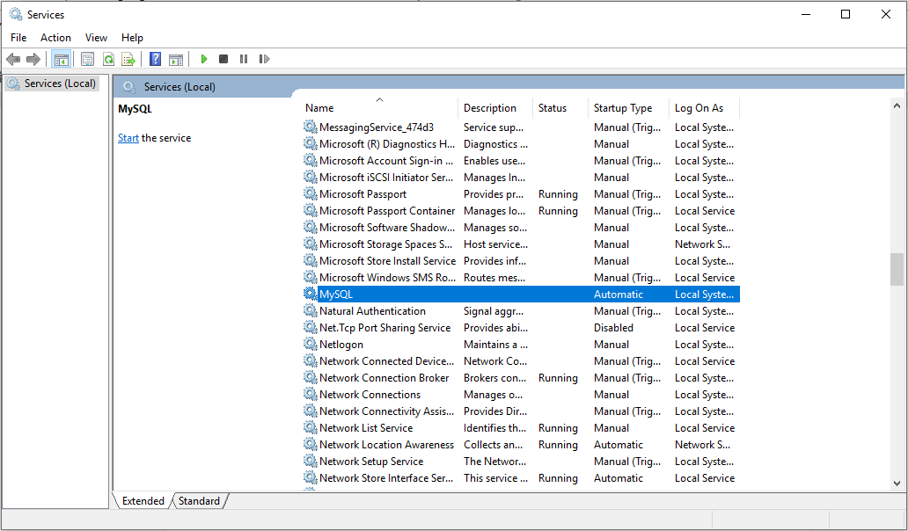

To Stop MySQL you need to do follow the same process.

To do same on terminal you need to do the following. Navigate to MySQL server 5.7 installation location

D:\Program Files\MySQL\MySQL Server 5.7\bin>

First thing first now:

**Run “mysqld.exe --install” this is to install the daemon service so as we could install**

Then we also need to create data directory as it’s not created by default under

**D:\Program Files\MySQL\MySQL Server 5.7\**

Then we would need to run the following command to initialize the mysqld , so run

D:\Program Files\MySQL\MySQL Server 5.7\bin> **.\mysqld --initailize**

First let’s check if the service is running. Run **sc query mysql** , this will give us following output

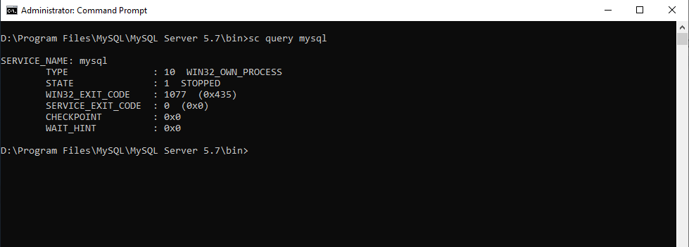

Then we need to run a set of commands

D:\Program Files\MySQL\MySQL Server 5.7\bin>**net start mysql**

Once you run the above mentioned command you will get the following result output

The MySQL service is starting..

The MySQL service was started successfully.

Congrats ! we’ve successfully started MySQL.

To stop MySQL you need to run following command:

D:\Program Files\MySQL\MySQL Server 5.7\bin>**net stop mysql**

**Creating Database, Connecting to Database,**

**Connecting to MySQL and creating Database.**

To connect to database you need to run following command:

**mysql -u root -p**

You will be prompted for root password, enter the same and hit enter.

Once done we will see the following screen if successful

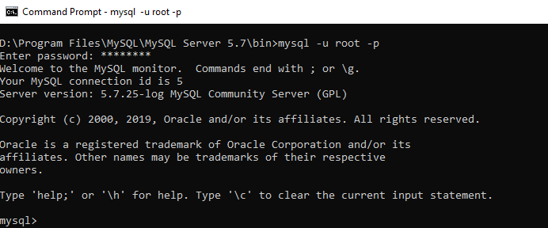

Now, lets create a new database.

Run following command at the prompt:

**create database newdb**;

We will get following prompt:



Let’s create and grant privieges to a user to be able to connect to the database, to do so run :

First select the db:

**use newdb;**

Than run :

**GRANT ALL PRIVILEGES ON newdb.* TO 'mashrur'@'localhost' identified by 'Password';**



Now that is done, we have to granted privileges to our user on newdb,

Now we shall see if we can connect to DB, hit exit and then run following command:

**mysql -u mashrur -p** and than provide the password

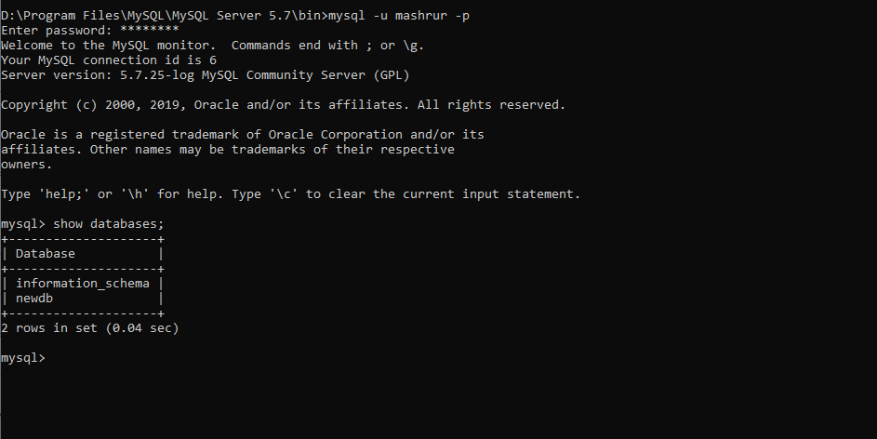

Creating Tables;

To create tasks tables as our user Mashrur, we have to run a few sets of commands:

**use newdb;**

**create table tasks(task_id INT, title VARCHAR(255) NOT NULL);**

The above table will create the table tasks with task id as INT, title as VARCHAR



That’s all we’ve created our DB, Created a user and connected to it. Moving ahead, we had created created a table and granted privileges etc….